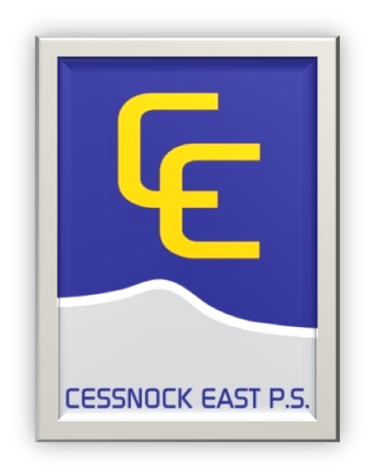
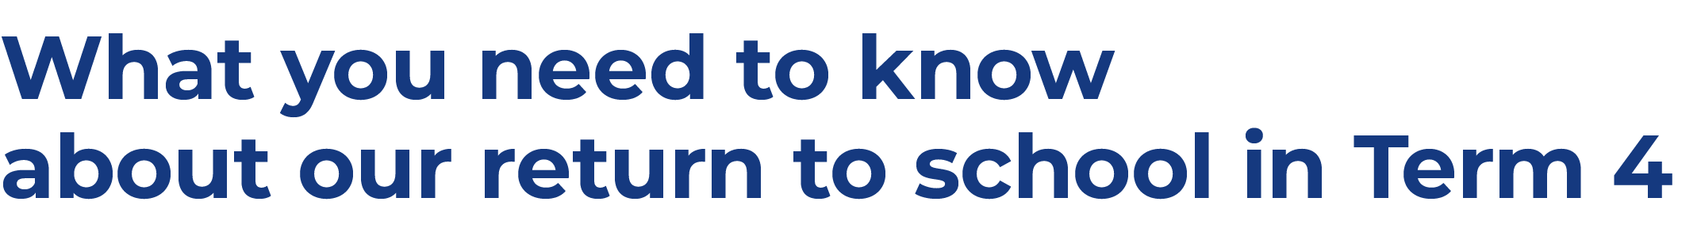
We’re excited about our return to face-to-face learning and welcoming students and staff back onsite where we know the best learning happens. This is a short summary of what our parents and students can expect. There will be many updates sent out this week with more details on what the return to face-to face schooling will look like for the students of Cessnock East Public School.
While we know there is excitement about the return to school it’s important that we stick to the staged return to give us time to be ready to welcome back students onsite. Students will return to face-to-face learning in the following order
- from 18 October – department preschool, Kindergarten, Year 1
- from 25 October – all remaining year groups.
Our COVID-safe return to school plan is NSW Health approved and includes numerous effective practices to support the health and wellbeing of our students and staff. These practices include vaccinations, mask wearing, reduced mingling of student groups and staff, ventilation in classrooms and continued good hygiene and cleaning.
As we return to school students will be kept in their cohorts to minimise opportunities for transmission of COVID-19 and to enable effective contact tracing and containment. This means minimising interaction between students on school grounds and keeping cohorts together where possible.

Cessnock East Public School will operate in Stage groups. This means that Kindergarten – KR and KS - will stay as one in the Early Stage 1 group. 1P, 1/2W and 2S will form the Stage 1 group. 3H, 3/4G and 4W will form the Stage 2 group. 4/5B, 5/6M and 6S will form the Stage 3 group.
Each Stage group will be allocated a different section of the playground to use at break times for the school week. Recess and lunch breaks will be staggered. Years 3-6 will have recess at 10:40am and their lunch time will start at 12:15pm. K-2 will have recess at the usual time of 11am and lunch at the usual time of 1pm.
We will return to staggered finish times for students from Monday 18th October 2021. Students will leave the school in their house groups so that families are able to collect their children at the one time. If you are unsure which house group your child is in, please check with their teacher, or call the school on 49901549.
Shakespeare will leave from Gate 5 and Newman will leave from Gate 4 at 2:55pm. This will give parents time to leave before the next group of students leave the school.
Drinkwater will leave from Gate 5 and Dodds will leave from Gate 4 at 3pm.
Students who are catching a bus, walking or riding home will leave the school at 3pm.

Masks are required to be worn on school site by staff indoors and outdoors and are strongly recommended for students indoors and outdoors unless exercising or eating.
You are welcome to send your child to school with a mask to wear, but please make sure your child’s name is written clearly on the outside of the mask. It is also very important to have a conversation with your child about only wearing his/her own mask.
The school does have a supply of students masks. If you would like one for your child, please call the school office on 49901549 and we will organise this for you.
All staff required on site supporting the return to school will need to be fully vaccinated from 18 October. Then from 8 November all staff, contractors, volunteers and students on student placement on a school site will need to be fully vaccinated, including Outside of School Hours Care staff.
We are encouraging our school community to take up a vaccine as soon as possible.
Having open or well-ventilated spaces reduces the risk of transmission of COVID-19 because infectious particles are more quickly diffused in the open air. The department will continue to work with NSW Health to provide us with advice and guidance on maintaining good ventilation in our school and we will make use of our outdoor spaces wherever practical.
At Cessnock East Public School we are lucky to have so many outdoor learning spaces. Our school has been inspected to make sure our windows open and our ceiling fans work.
During Term 4 many school-based activities will remain on hold until NSW Health advise otherwise. This includes large celebrations like assemblies, presentation days and graduations, arts and sports events.
Unfortunately, school based programs such as Scripture and the Sports in School program will no longer run. We look forward to these programs returning in 2022.
Parents and students will be notified if a decision is made to close the school due to a confirmed case of
COVID-19. During this time we will continue to provide learning from home activities and we will let you know when we can return to face-to-face learning.
If this were to happen, we would communicate with our school community using the Skoolbag and Sentral app. If you do not have these apps, please download them as soon as possible. If you need assistance with this, contact the school office on 49 901549 as we are happy to help you.
Out of school hours care, vacation care settings and preschools operating on school sites will follow the same COVID-safe guidelines as public schools including the requirement to be fully vaccinated from 8 November.
The Hunter Mobile Preschool will be back on site from Monday 18th November. Staff from the preschool will be in touch with families to explain any changes that will occur.
Onsite orientations and transition programs are not currently allowed in person on school sites until we are advised differently by NSW Health. We’ll share more information in the coming weeks about our school’s virtual orientation and transition program.
At Cessnock East Public School we will begin with a virtual orientation program and hopefully, if the guidelines change, we will have our 2022 Kindergarten students on site later in Term 4. We will be in contact with families to explain how to this program will run.

